**TASK # 1: Design the following Form by using necessary concepts of Bootstrap.**

<!DOCTYPE html>

<html>

<head>

    <title></title>

    <meta charset="utf-8" />

    <link href="Content/bootstrap.css" rel="stylesheet" />

    <link href="Content/bootstrap.min.css" rel="stylesheet" />

</head>

<body>

    <div class="container">

            <div>

                    <legend class="">Register</legend>

            </div>

        <form class="form-horizontal">

                <div class="row">

                    <div class="form-group">

                        <div class="col-md-3">

                            <input type="text" class="form-control" id="fname" placeholder="First Name" />

                        </div>

                        <div class="col-md-3">

                            <input type="text" class="form-control" id="lname" placeholder="last Name" />

                        </div>

                    </div>

                </div>

                <div class="row">

                    <div class="form-group">

                        <div class="col-md-6 ">

                            <input type="text" class="form-control" id="lname" placeholder="last Name" />

                        </div>

                    </div>

                </div>

                <div class="row">

                    <div class="form-group">

                        <div class="col-md-6 ">

                            <input type="text" class="form-control" id="lname" placeholder="last Name" />

                        </div>

                    </div>

                </div>

                <div class="row">

                    <div class="form-group">

                        <div class="col-md-3">

                            <input type="text" class="form-control" id="fname" placeholder="First Name" />

                        </div>

                        <div class="col-md-3">

                            <input type="text" class="form-control" id="lname" placeholder="last Name" />

                        </div>

                    </div>

                </div>

                <div class="row">

                    <div class="form-group">

                        <div class="col-md-2">

                            <button class="btn btn-secondary" id="confirmbtn">I agree</button>

                        </div>

                        <div class="col-md-4">

                            <p>By clicking agree you agee to terms and conditions set out by this site including our cookie use</p>

                        </div>

                    </div>

                </div>

                <div class="row">

                    <div class="form-group">

                        <div class="col-md-3">

                            <button class="btn btn-primary btn-block" id="confirmbtn">I agree</button>

                        </div>

                        <div class="col-md-3">

                            <button class="btn btn-success  btn-block" id="confirmbtn">I agree</button>

                        </div>

                    </div>

                </div>

        </form>

    </div>

</body>

</html>

**OUTPUT:**

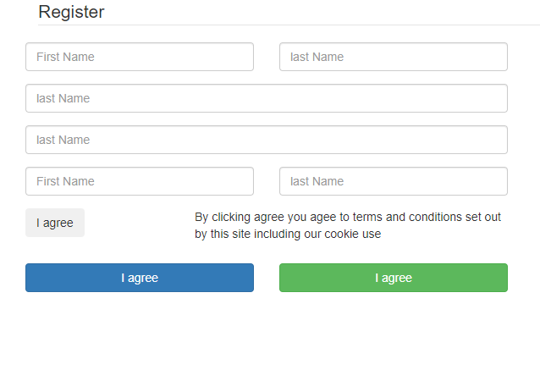

**TASK # 2:** **Design the following 3D buttons by using necessary concepts of Bootstrap.**

<!DOCTYPE html>

<html>

<head>

    <title></title>

    <meta charset="utf-8" />

    <link href="Content/bootstrap.css" rel="stylesheet" />

    <link href="Content/bootstrap.min.css" rel="stylesheet" />

</head>

<body>

    <div class="container">

        <h1 class="text-center">Bootstrap Buttons</h1>

        <div class="row col-md-offset-3">

            <button class="btn btn-default">Default</button>

            <button class="btn btn-primary">primary</button>

            <button class="btn btn-success">success</button>

            <button class="btn btn-info">info</button>

            <button class="btn btn-warning">warning</button>

            <button class="btn btn-danger">danger</button>

        </div>

    </div>

</body>

</html>

**OUTPUT**

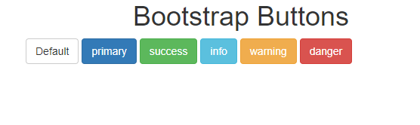

**TASK # 3 : Create the your Semester Time Table using Bootstrap.**

<!DOCTYdivE html>

<html>

<head>

    <title></title>

    <meta charset="utf-8" />

    <link href="Content/bootstrap.css" rel="stylesheet" />

    <link href="Content/bootstrap.min.css" rel="stylesheet" />

   <style>

     .container .row .col-lg-1{

         border: 1px solid #c9c9c9;

         padding:15px;

     }

   </style>

</head>

<body>

    <div class="container">

        <h1 class="text-center">Timetable</h1>

    <div class="row">

        <div class="col-lg-1"> Day of week </div>

        <div class="col-lg-1">08:30-9:25</div>

        <div class="col-lg-1">09:30-10:25</div>

        <div class="col-lg-1">10:30-11:25</div>

        <div class="col-lg-1">11:30-12:25</div>

        <div class="col-lg-1">12:30-13:25</div>

        <div class="col-lg-1">13:30-14:25</div>

        <div class="col-lg-1">14:30-15:25</div>

        <div class="col-lg-1">15:30-16:25</div>

        <div class="col-lg-1">16:30-17:25</div>

    </div>

    <div class="row">

        <div class="col-lg-1">Monday</div>

        <div class="col-lg-1">No class</div>

        <div class="col-lg-1">No class</div>

        <div class="col-lg-1">EAK s301</div>

        <div class="col-lg-1">FH s301</div>

        <div class="col-lg-1">EAR s307</div>

        <div class="col-lg-1">EAR s307</div>

        <div class="col-lg-1">DOR s307</div>

        <div class="col-lg-1">No class</div>

        <div class="col-lg-1">No class</div>

    </div>

    <div class="row">

        <div class="col-lg-1">Tuesday</div>

        <div class="col-lg-1">No class</div>

        <div class="col-lg-1">No class</div>

        <div class="col-lg-1">No class</div>

        <div class="col-lg-1">ear lab 9</div>

        <div class="col-lg-1">ear lab 9</div>

        <div class="col-lg-1">ear lab 9</div>

        <div class="col-lg-1">EBF s307</div>

        <div class="col-lg-1">EBF s307</div>

        <div class="col-lg-1">No class</div>

    </div>

    <div class="row">

        <div class="col-lg-1">Wednesday</div>

        <div class="col-lg-1">No class</div>

        <div class="col-lg-1">No class</div>

        <div class="col-lg-1">No class</div>

        <div class="col-lg-1">EAK s308</div>

        <div class="col-lg-1">EAK s308</div>

        <div class="col-lg-1">No class</div>

        <div class="col-lg-1">DOR s308</div>

        <div class="col-lg-1">DOR s308</div>

        <div class="col-lg-1">No class</div>

    </div>

    <div class="row">

        <div class="col-lg-1">divursday</div>

        <div class="col-lg-1">DBF lab 2</div>

        <div class="col-lg-1">DBF lab 2</div>

        <div class="col-lg-1">DBF lab 2</div>

        <div class="col-lg-1">No class</div>

        <div class="col-lg-1">FH s307</div>

        <div class="col-lg-1">FH s307</div>

        <div class="col-lg-1">No class</div>

        <div class="col-lg-1">No class</div>

        <div class="col-lg-1">No class</div>

    </div>

    <div class="row">

        <div class="col-lg-1">Friday</div>

        <div class="col-lg-1">No class</div>

        <div class="col-lg-1">No class</div>

        <div class="col-lg-1">ewqks301</div>

        <div class="col-lg-1">ewqks301</div>

        <div class="col-lg-1">No class</div>

        <div class="col-lg-1">No class</div>

        <div class="col-lg-1">MZI s401</div>

        <div class="col-lg-1">MZI s401</div>

        <div class="col-lg-1">MZI s401</div>

    </div>

    </div>

</body>

</html>

**OUTPUT:**

